WEEK 1 PROJECT PLAN
Urban Air Quality Category Prediction
Data Science Project Planning & Strategy Design

Project Domain | Environment / Data Science / Machine Learning
ML Task | Multi-class Classification
Primary Language | Python
Planned Effort | 33 hours
Project Stage | Planning and Strategy — Week 1

Prepared as a conceptual, end-to-end Python data science plan

1. Executive Summary
This project proposes an end-to-end Python-based machine learning solution for predicting an urban air-quality category from pollutant and environmental observations. The planned input variables include particulate-matter indicators (PM2.5/PM10), NO₂, temperature, humidity, wind-related variables, and other available environmental measurements. The target will be a clearly defined multi-class air-quality category derived from an established classification scheme or from the project dataset's provided labels.
The project is intentionally planned before technical implementation. The strategy covers problem definition, data sourcing, quality checks, exploratory data analysis (EDA), feature engineering, baseline and candidate classification models, validation, interpretation, documentation, and communication of results. The plan allocates 33 hours so that technical work is balanced with data understanding, evaluation, and reporting.

Project-at-a-Glance
Item | Planned Decision
Business question | Can observed pollution and environmental conditions be used to classify urban air quality?
Prediction target | Air-quality category (multi-class)
Core inputs | PM indicators, NO₂, temperature, humidity, wind-related variables
Primary success measure | Macro F1-score, supported by per-class precision/recall and confusion matrix
Validation approach | Stratified train/test split and cross-validation on training data
Deliverable | Reproducible Python workflow, evaluation report, and recommendations

2. Project Background and Problem Definition

2.1 Background
Urban air quality can vary substantially across time and location because of emissions, atmospheric conditions, weather, traffic, industrial activity, and dispersion patterns. A data science workflow can use observed pollutant and environmental measurements to identify patterns and classify observations into interpretable air-quality categories.

2.2 Hypothetical Problem Statement
Develop a Python-based multi-class classification system that predicts the air-quality category associated with an observation using pollutant and environmental features. The system should emphasize reliable data preparation, transparent evaluation, and practical interpretation rather than simply maximizing a single accuracy value.

2.3 Motivation
- Convert multiple environmental measurements into an easily interpretable category.
- Identify which measured variables are associated with different air-quality classes.
- Create a repeatable machine learning workflow that can be updated as new observations become available.
- Demonstrate a complete professional data science process from problem definition through communication.
- Support exploratory environmental analysis without claiming that the model alone establishes causal relationships.

3. Project Objectives and Scope

3.1 Specific Objectives
- Define a precise target variable and document the air-quality category definitions used.
- Identify suitable pollutant, meteorological, and contextual input variables.
- Assess data quality, missingness, duplicates, inconsistent units, invalid ranges, and potential leakage.
- Perform descriptive statistics and visual EDA to understand distributions, relationships, class balance, and outliers.
- Engineermeaningful features where justified by domain logic and available data.
- Establish a simple baseline classifier and compare it with selected machine learning models.
- Evaluate the models using class-aware metrics and error analysis.
- Document limitations, risks, assumptions, and recommendations for future iterations.

3.2 In Scope
- Tabular environmental observations.
- Multi-class classification of air-quality categories.
- Python-based data preparation, EDA, feature engineering, modeling, validation, and reporting.
- Model comparison using reproducible train/test methodology.
- Interpretability through feature importance or model-agnostic explanations where practical.

3.3 Out of Scope
- Building or deploying physical air-quality sensors.
- Real-time production deployment or public alert infrastructure.
- Causal inference about the source of pollution.
- Long-term atmospheric chemistry simulation.
- Medical or health-risk diagnosis based on predicted categories.
- Guaranteeing predictions for locations or conditions not represented in the training data.

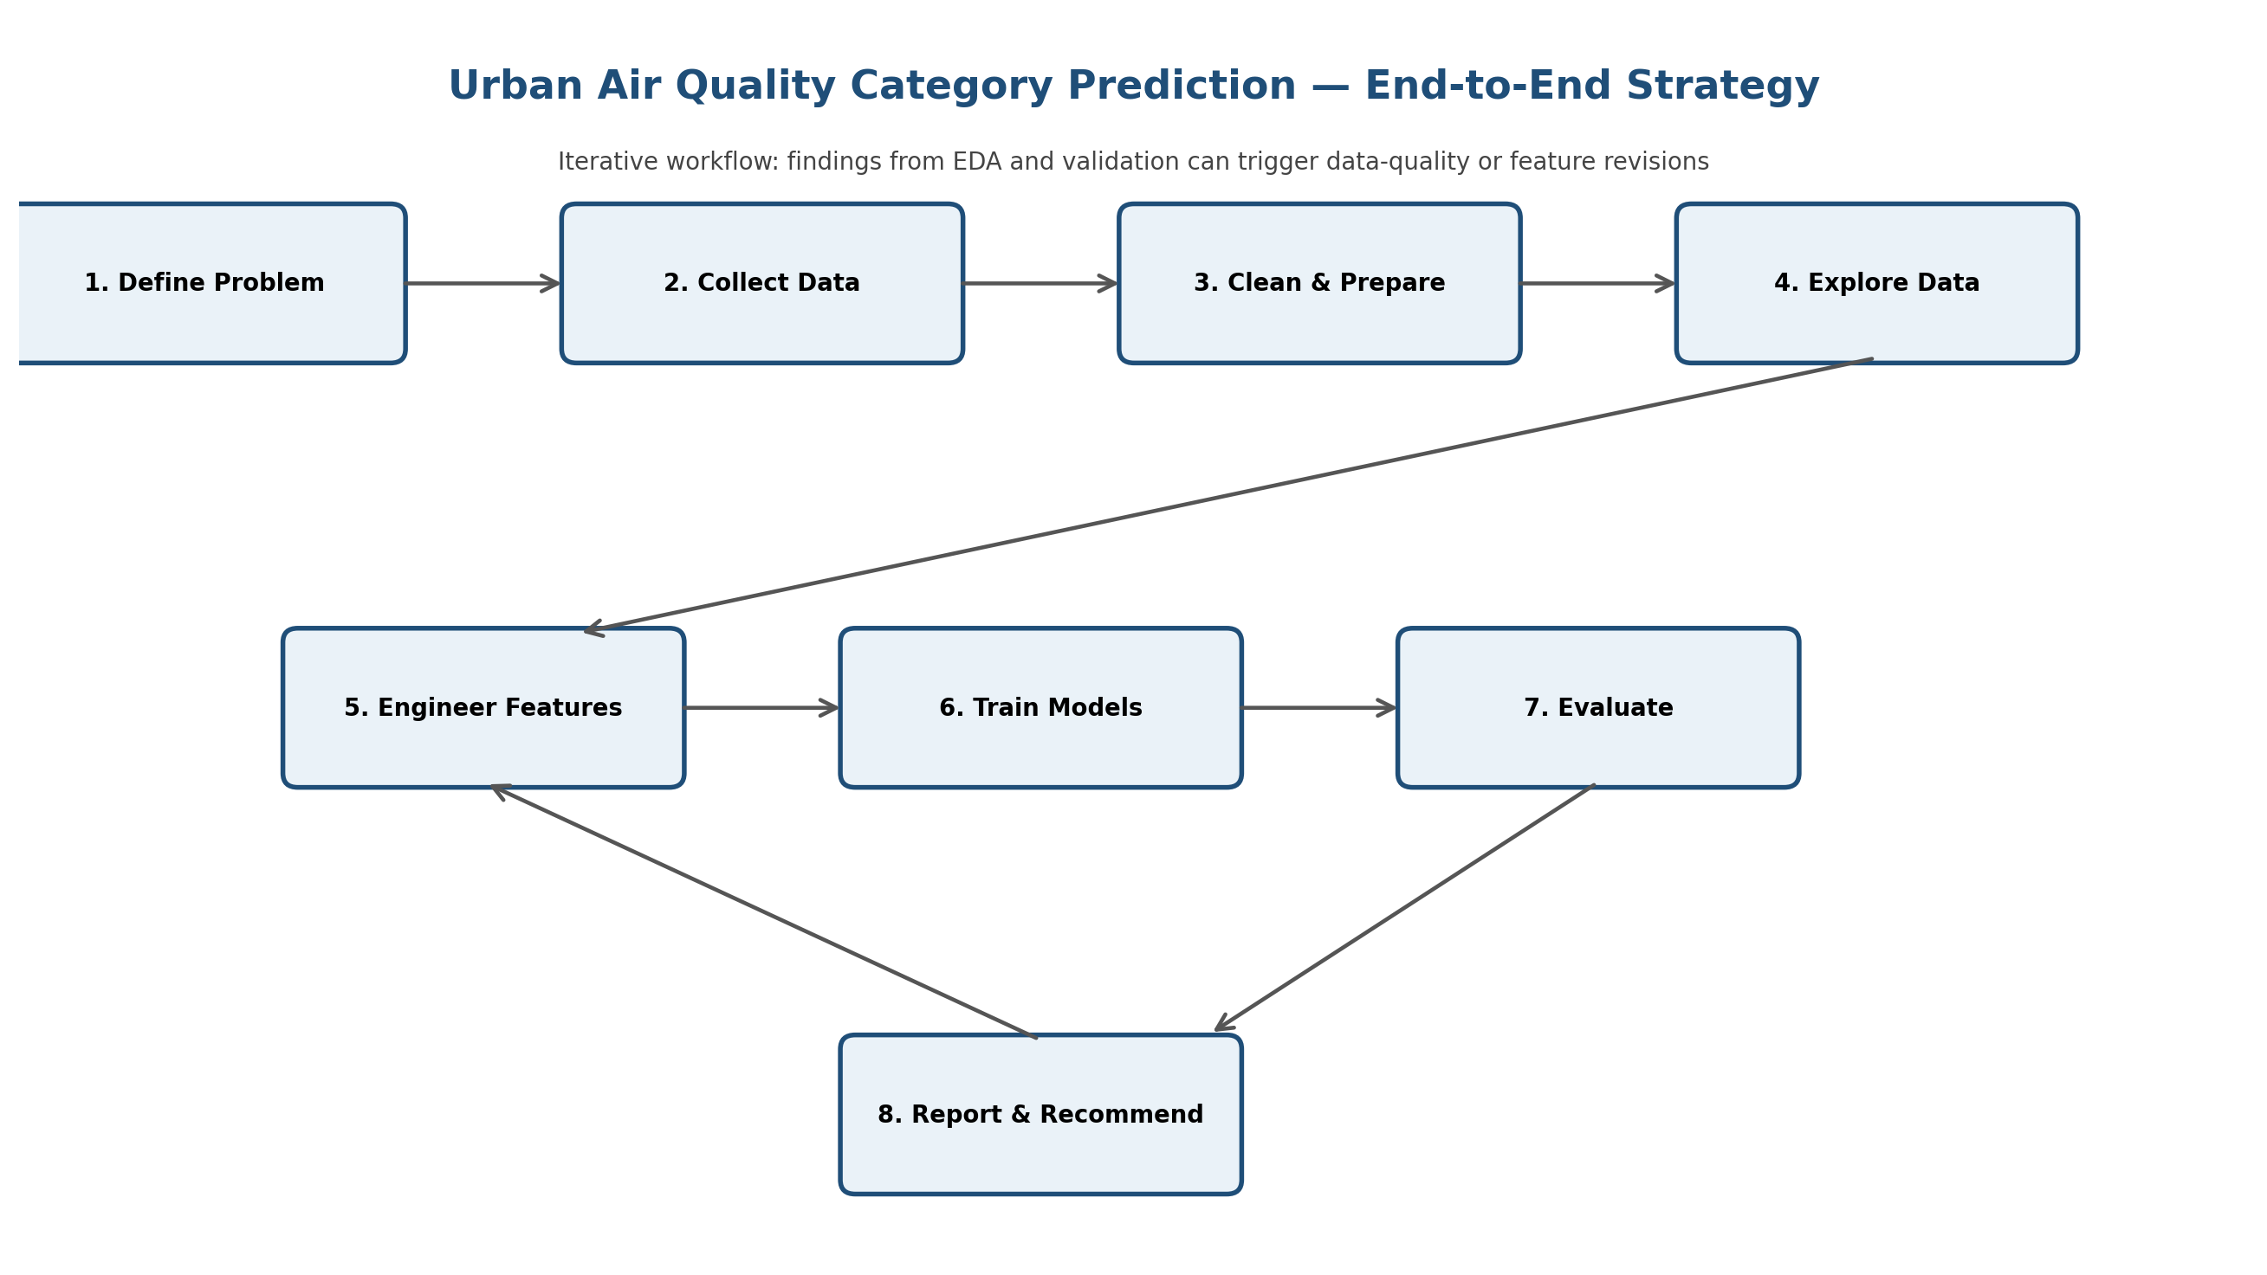
Figure 1. Planned end-to-end workflow

4. Methodology and Strategy
The project will follow an iterative CRISP-DM-style workflow adapted for a Python machine learning project. Although the stages are presented sequentially, findings from data exploration and validation may require returning to earlier stages.

4.1 Stage 1 — Problem and Data Understanding
- Define the unit of observation: e.g., a monitoring-station reading at a particular timestamp.
- Confirm the target category definitions and whether the labels are supplied or need to be derived.
- Create a data dictionary containing variable names, units, meaning, expected ranges, and source.
- Identify the intended prediction setting to prevent target leakage.

4.2 Stage 2 — Data Collection Strategy
Potential data sources will be selected based on availability, licensing, completeness, and consistency. The planned source hierarchy is:
- Assigned project dataset, if provided.
- Open government or environmental datasets with documented measurements and metadata.
- Public weather observations or APIs where their usage terms permit project use.
- Supplementary contextual variables only when they can be aligned reliably with the primary observations.
Each source will be documented with source name, access date, geographic coverage, time period, units, licensing or usage notes, and known limitations.

4.3 Stage 3 — Data Cleaning and Preparation
Check | Planned action | Purpose
Schema check | Confirm column names, data types, units, and target representation. | Prevent inconsistent processing.
Missing values | Quantify missingness; investigate patterns; impute only when justified. | Avoid biased or unnecessary imputation.
Duplicates | Identify exact and potential duplicate observations. | Prevent repeated records from influencing training.
Invalid values | Check physical/domain ranges and impossible values. | Replace, correct, or exclude using documented rules.
Outliers | Use boxplots, distributions, and domain context. | Do not automatically delete legitimate extreme pollution events.
Leakage | Check whether any feature contains future/derived target information. | Protect evaluation validity.
Splitting | Separate train/test before learned transformations. | Avoid information leakage.

4.4 Stage 4 — Exploratory Data Analysis
- Inspect numerical distributions using histograms and summary statistics.
- Compare feature distributions across air-quality classes.
- Use boxplots to identify extreme observations and class-specific patterns.
- Examine correlations among numeric variables while remembering that correlation does not imply causation.
- Check class balance using counts and percentages.
- Investigate time or location patterns if those variables are available and appropriate.
- Record EDA findings as explicit decisions that influence later feature engineering or modeling.

4.5 Stage 5 — Feature Engineering
- Create carefully justified derived features such as pollutant ratios or combined weather indicators when domain meaning is clear.
- Extract time-based features such as hour, day-of-week, or month if timestamps are available and prediction-time availability is realistic.
- Encode categorical variables where necessary.
- Scale numeric features for algorithms that are sensitive to feature magnitude.
- Keep transformations reproducible using a pipeline so the same operations are applied during validation and future inference.

4.6 Stage 6 — Model Strategy
Model family | Candidate | Reason for inclusion
Baseline | Dummy classifier / majority class | Reference point; establishes minimum useful performance.
Linear | Logistic Regression | Interpretable baseline for multi-class classification.
Tree-based | Decision Tree | Captures non-linear relationships; easy to inspect.
Ensemble | Random Forest | Robust non-linear model and useful feature-importance baseline.
Optional | Gradient boosting model | Candidate for stronger predictive performance if time permits.

4.7 Stage 7 — Evaluation Strategy
Because the target has multiple classes, evaluation will not rely on accuracy alone. The primary comparison metric will be macro F1-score so that each class contributes equally to the summary measure.
- Macro F1-score — primary class-balanced comparison metric.
- Per-class precision — how often predicted members of a class are correct.
- Per-class recall — how well observations belonging to each class are detected.
- Confusion matrix — identifies which categories are commonly confused.
- Accuracy — reported as a supplementary overall measure.
- Cross-validation results — estimate performance stability on the training data.
- Error analysis — inspect representative misclassifications and data conditions associated with them.

4.8 Stage 8 — Interpretation and Reporting
The final report will connect model results back to the original problem. It will clearly separate observed data patterns, model behavior, and practical recommendations. No causal claims will be made solely from predictive relationships.

5. Conceptual Solution Architecture
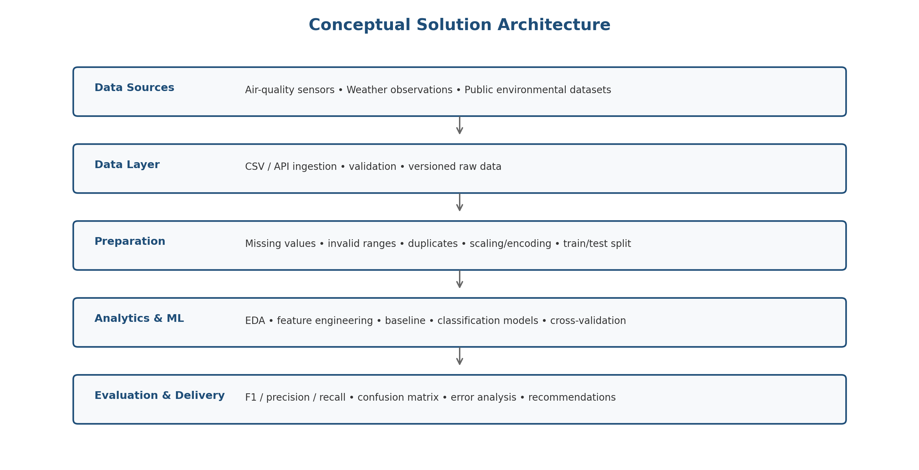
Figure 2. Conceptual architecture from data sources to evaluated outputs.
The architecture is designed to keep raw data, preparation, modeling, and evaluation conceptually separate.
This makes the project easier to debug, reproduce, and extend.

6. Timeline and 30-35 Hour Work Allocation
The planned workload is 33 hours. The allocation deliberately reserves time for documentation and interpretation, not just model training.
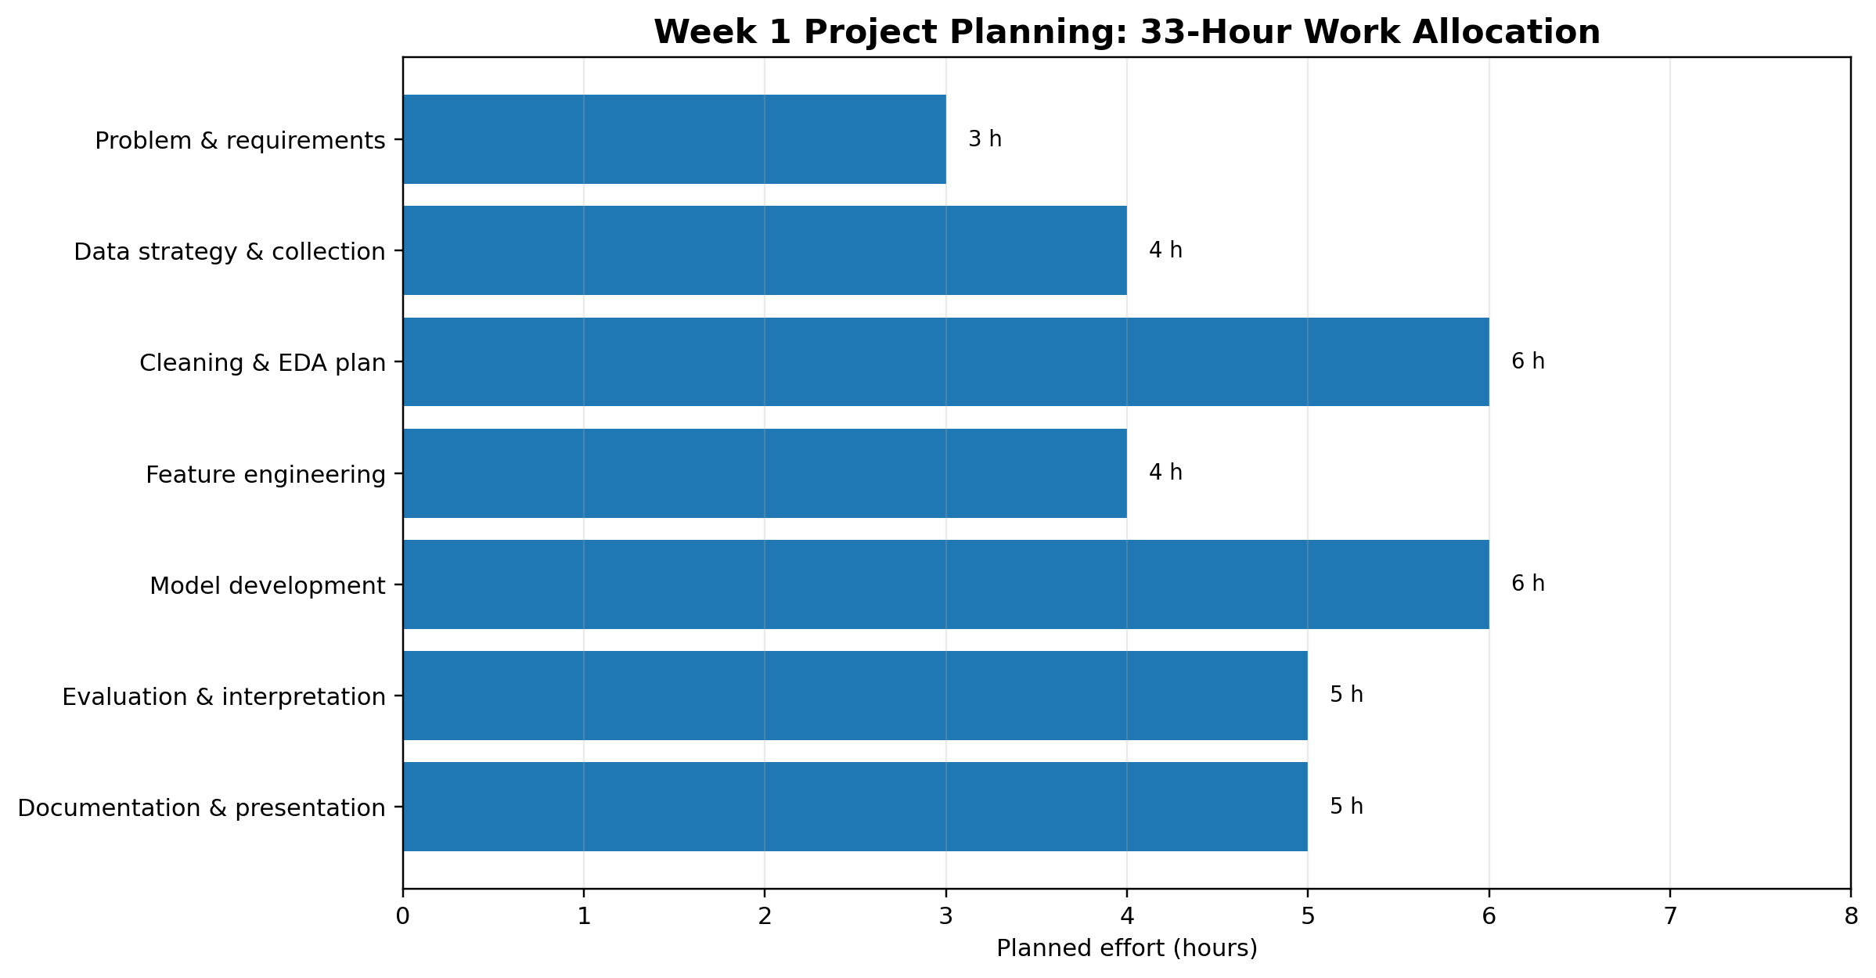
Figure 3. Planned 33-hour effort distribution.
Phase | Work package | Key activities | Hours
1 | Problem definition&requirements | Define target, scope, assumptions, success criteria | 3
2 | Data strategy&collection | Identify sources, fields, units, metadata, access process | 4
3 | Cleaning&EDA planning | Quality rules, missingness, duplicates, distributions, class balance | 6
4 | Feature engineering | Candidate derived variables and preprocessing strategy | 4
5 | Model development | Baseline, candidate models, training pipeline | 6
6 | Evaluation&interpretation | Metrics, confusion matrix, error analysis, model comparison | 5
7 | Documentation&presentation | Report, diagrams, conclusions, limitations, reproducibility notes | 5

Total planned effort: 33 hours.

7. Tools, Technologies, and Python Libraries
Tool / Library | Role | Planned use
Python | Primary programming language | Data processing, EDA, modeling
Jupyter Notebook / VS Code | Development environment | Exploration, experimentation, documentation
pandas | Tabular data processing | Loading, cleaning, transformation
NumPy | Numerical computing | Arrays, numerical operations
Matplotlib | Visualization | Histograms, boxplots, charts
Seaborn | Statistical visualization | Correlation heatmaps and grouped plots
scikit-learn | Machine learning | Splitting, preprocessing, models, metrics, pipelines
SciPy (optional) | Scientific computing | Statistical utilities where required
Git / GitHub | Version control | Track code and documentation changes

Reproducibility Practices
- Use fixed random seeds where appropriate.
- Keep raw data separate from cleaned/derived data.
- Record package versions for the final experiment.
- Use a preprocessing/model pipeline to prevent inconsistent transformations.
- Keep an experiment log containing model, parameters, validation method, and metrics.
- Document assumptions and data-quality decisions instead of silently modifying records.

8. Expected Outcomes and Deliverables
- A clearly defined multi-class air-quality prediction problem.
- A documented data dictionary and data-quality assessment.
- A cleaned and analysis-ready dataset or reproducible preparation pipeline.
- EDA visualizations showing distributions, relationships, class balance, and potential anomalies.
- A feature-engineering plan with justified derived variables.
- A baseline and several candidate classification models.
- A model comparison using macro F1, per-class metrics, confusion matrix, and supplementary accuracy.
- An interpretation of important predictors and common classification errors.
- A final technical report/notebook explaining methodology, results, limitations, and next steps.

9. Anticipated Challenges and Mitigation Strategies
Challenge | Risk | Mitigation
Class imbalance | Minority air-quality categories may be underrepresented. | Use stratified splitting; report per-class metrics; consider class weights or resampling only after diagnosing imbalance.
Missing measurements | Sensors or weather sources may have gaps. | Quantify missingness; investigate why it occurs; use justified imputation or exclusion rules.
Outliers | Extreme pollution events may appear unusual but can be genuine. | Combine statistical checks with domain context; avoid automatic deletion.
Feature leakage | A variable may indirectly encode the target or future information. | Inspect feature definitions and enforce time-aware availability assumptions.
Multicollinearity | Pollutant variables may be strongly related. | Inspect correlations; use regularization or tree-based models; interpret coefficients cautiously.
Temporal drift | Relationships can change across seasons or years. | Track time coverage; use time-aware validation if prediction is future-facing.
Location differences | Stations can have different pollution profiles. | Include location context when valid; test generalization across locations where feasible.
Overfitting | Flexible models can memorize the training data. | Use cross-validation, appropriate regularization, and a locked test set.
Interpretability | High-performing models may be harder to explain. | Compare with interpretable baselines and use feature-importance/explanation methods carefully.

10. Evaluation Criteria and Project Success Definition
The project will be considered successful when it demonstrates a complete, logically connected data science process and produces an evaluation that is trustworthy enough to support the stated project objective.
Criterion | Evidence of success
Completeness | All major data science stages are documented from problem definition to reporting.
Data quality | Cleaning decisions are explicit, reproducible, and supported by checks.
EDA quality | Visual and numerical analysis answers relevant project questions.
Modeling | At least one baseline and multiple suitable classifiers are compared.
Evaluation | Class-aware metrics, confusion matrix, and error analysis are reported.
Reproducibility | Code structure, preprocessing, seeds, and experiment settings are documented.
Communication | Charts, diagrams, tables, and conclusions are clear and logically organized.
Professional judgment | Limitations and uncertainty are stated; predictive relationships are not presented as causal proof.

11. Data Ethics, Privacy, and Responsible Use
- Use only data that can legally and ethically be used for the project.
- Avoid collecting personally identifiable information when it is not required.
- Document data-source limitations and potential measurement bias.
- Do not present a model prediction as a medical diagnosis or a guarantee of safety.
- Communicate uncertainty and class-specific weaknesses rather than hiding poor performance.
- Treat the model as a decision-support or analytical tool, not an autonomous authority.

12. Future Enhancements
- Evaluate time-aware validation for forecasting-style use cases.
- Test generalization across monitoring stations or geographic areas.
- Add carefully selected traffic, land-use, or meteorological context if available.
- Investigate calibration so predicted class probabilities are more interpretable.
- Build a lightweight dashboard for exploratory monitoring after the offline model is validated.
- Automate data-quality checks and model monitoring for future datasets.

13. Conclusion
This Week 1 plan establishes a structured foundation for an Urban Air Quality Category Prediction project. The proposed approach prioritizes understanding the problem and data before modeling, uses class-aware evaluation, and allocates sufficient time to validation, interpretation, and documentation. The result will be a reproducible Python workflow that can move into the technical implementation phase once an appropriate dataset is available.

